*΄΄CONTRACT OF SERVICES OF THE NURSERY SCHOOL"*

***REGULATION OF OPERATION – PRIVATE AGREEMENT***



































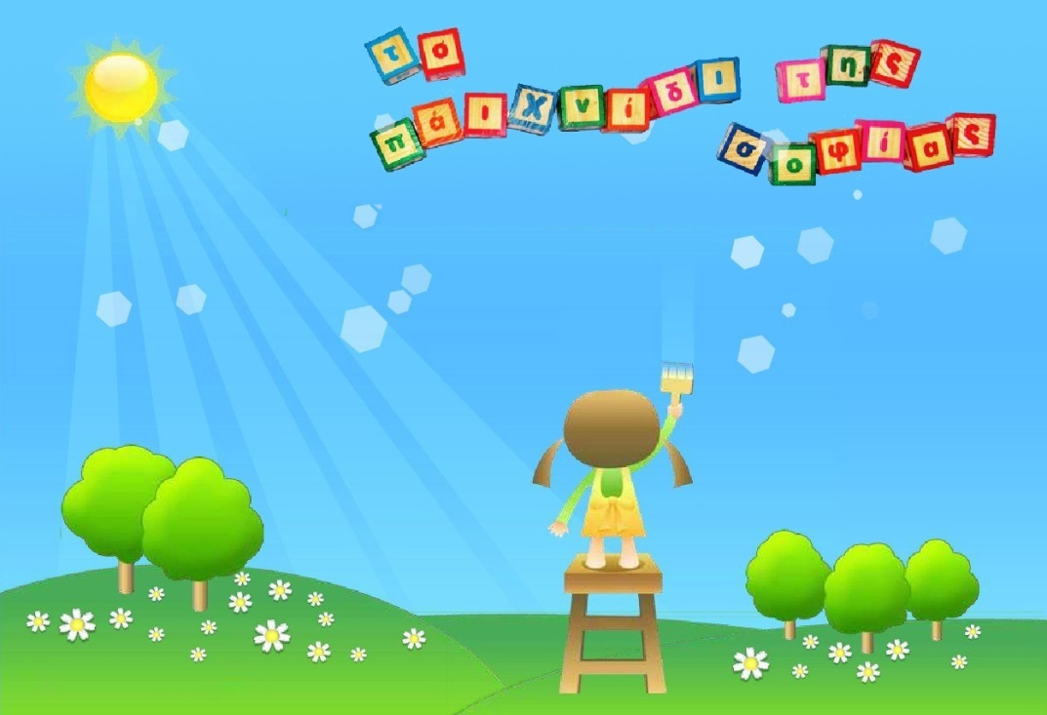



©Copyright June2021, The game of wisdom

The reproduction of any part of this product (photocopy, printing ,microfilm, or other mechanic or electronic method) without the permission of the publisher is strictly prohibited.

With the start of the new school year, we wish your children a happy new year and good progress. In addition, we want to point out some issues related to the proper operation of our kindergarten.

The school year starts on the 1st of September and ends on the 28th of July.

**🞜** The Arrival of the children in the kindergarten starts from 07:30 am. to 09:00 a.m. Departure hours are from 14:00 p.m. until 16:00 p.m. . The observance of the arrival and departure times of the children in the kindergarten is strictly **obligatory.** There is the possibility of extension of these hours. However, if the child stays at school after 15.00 there will be an additional cost per hour that comes up to 100 euros per month

**🞜** The afternoon leisure and creative activity is paid by the hour and is optional from 16:00 p.m. until 18:00 p.m.

**🞜** Please be precise with the scheduled boarding time of the school bus, so that there is consistency in the itinerary. Parents must have the child ready at the door five minutes earlier than the scheduled time. Αny delays will cause problems. We also ask parents if they do not need the school bus in the morning, to inform us at least half an hour in advance and at least one hour in advance for the afternoon itinerary. Parents must inform the Kindergarten on time in case the place where we pick up or leave the child changes (even temporarily), in order to do the best possible for the school and to serve the parents and the children. School bus delays are only due to traffic and therefore you need to show understanding.

**🞜**In case your child is absent please let us know, and if he/she uses the school bus inform us the previous day or early in the morning of the same day on the school phone leaving a message.

**🞜** The person who escorts the children in the school bus (apart from the driver) is obliged to stay in the school bus. Therefore, the guardian must make sure that the child is safely delivered and picked-up at the door of the school bus. Children must be picked up by members of their family (parents, grandparents) or by any third party that the parent / guardian has stated in writing. It would be preferable if the school staff knew this third party. The pick-up of the child by a third party should always be done upon presentation of the police ID of the adult recipient.

**🞜** Any children who have contagious diseases e.g. viruses or childhood illnesses, are prohibited from coming to the daycare center and must remain at home until fully recovered. Sick children need the peace and care of their home. The rest of the school children do not need the viruses and germs that a sick child carries. At the same time, the work of kindergarten teachers becomes extremely difficult, as they have to take care of sick children at the expense of others. School cannot be a convalescent home. When you are informed by the School about fever or other illness, which makes it necessary for the child to leave school, we kindly request that you pick up the child by your own means. Upon their return to school, a pediatrician's medical assessment is required.

**🞜** Children are not allowed to bring toys, jewellery as well as chips or other snacks like these.

**🞜** In each child's bag there should be a change of clothes and 3-4 diapers with baby wipes (if used), in case it gets dirty or wet.

**🞜** The kindergarten collaborates with a pediatrician-developmentalist and a psychologist-speech therapist, who visit us regularly. Also once a year there is a visit to the dentist - orthodontist.

**🞜** Parents are informed by the kindergarten teachers in person about the progress of the children in a monthly basis and daily through their notebook or an information letter. For this reason, parents are kindly requested not to use the school phone unnecessarily.

**🞜** The tuition fees: **1)** are annual and are paid with the advance payment given with the registration of the infant and two (2) equal installments which should be deposited in the first five days of September and February regardless of whether the child is absent in between. For any delay you must inform the Management of the kindergarten. In case of payment by check it should be daily. Only with the deposit of the advance payment of the tuition fees during the registration of the child, is our kindergarten obliged to secure a place for the child.

**2)** When registering the child, the parents are obliged to state in writing the exact time of when the hosting of the child starts. If for any reason, the child does not attend the kindergarten within the above agreed time, the parents are obliged to pay all the tuition fees corresponding to the period from the declared start of hospitality until the end of the school year. In this case the kindergarten ΄΄THE GAME OF WISDOM ΄΄ reserves the right to grant the place of hosting to another child.

**3)** In the event that the parents, voluntarily, permanently or temporarily stop the hosting of the child before the end of the school year, they are obliged to pay the tuition for the entire school year.

**4)** In case of delay in the payment of all or part of the tuition, the debt will be charged with the legal, each time, default interest. The School may terminate hosting of the child when the parents do not pay their financial obligations for a period of more than two (2) months and after they are first notified to pay the amount due. As tuition fees are the only financial resource of our school, it is necessary for the parents/ guardians to pay on time any financial obligations within the agreed time limits, according to this private agreement, as this makes the planning of educational activities of our school possible and at the same time its smooth operation is ensured.

**5)** The agreed annual cost of tuition is ………………………………………………. The final payment of this amount should be made by May 10.

**6)** The agreed annual cost for the school transportation depending on the selected routes (1 route, morning or afternoon, or 2 routes) is …………………………….The final payment of this amount should be made by May 10.

**7)** For those parents who will pay all school fees by September 30, there will be a 10% discount on all tuition fees. Example :( 7150-10% = 6435) babies, (6050-10% = 5445) from 2.5 year-olds and up.

**8)** The annual cost of performances, theaters, photographs, costumes, etc. is up to 350 euros. This amount corresponds to each child individually. In case of a second child in the same family, there is a 10% discount for the second child.

**9)** In case the parents choose one of the extra activities, they are obliged to pay the agreed amount by the 31st of December 202...

Tae kwon do will take place once a week for 9 months (October to May) with an annual cost of 220 euros.

Ballet will take place once a week for 9 months (October to May) with an annual cost of 220 euros.

Gym class will take place once a week for 9 months (October to May) with an annual cost of 220 euros

Swimming classes will be held by the school once a week and the parents have the right for one more time, after consultation with the managers of the swimming pool. The annual cost is 350 euros. The swimming classes last from October to June.

**🞜** PERSONAL DATA-PRIVACY POLICY The School processes the data that you yourself provide us with, either directly or from the various actions of the school and school life, in the framework of the existing contract. The personal data that you provide us with, either for the fulfillment of the contract between the provision of education services, or because the law requires it, is in particular, your name, patronymic, email, mobile / landline, address of residence or business, tax information ( VAT number), bank accounts (in case of tuition refund, for example), the name and date of birth of your child or the name and contact telephone number of the people whom you have entrusted to pick up or take care of the child (eg details of grandparents ) etc.

In any case, the data we collect and process is limited to the minimum necessary to fulfill the purposes of the contract with you and its related purposes, as well as the purposes of the laws governing the reasons for collection and processing. The reasons we process this data are a) the contract between us, b) reasons for the safety of your child, so that we can contact you immediately, or provide immediate medical assistance, if there is an urgent need c) tax legislation. We make sure that all the above files are updated and checked regularly (eg when a student leaves school). In addition, all data collected electronically and processed in electronic form is encrypted to ensure greater security against malicious third party actions. Each user of this data (associate employees) uses passwords for the data being processed. Data stored in physical files are also protected from the interference of unauthorized people. This information, especially that of the children, may be disclosed to associates for the promotion of School activities or for the safety and protection of your children's health and life (eg to the collaborating photographers who cover the various activities and school events, to associates for the management of websites and social media pages, the pediatrician visiting the school, the hospital where the child may be transported in the event of an accident, etc.). We process this data for as long as the contract between us lasts and for as long as required by the tax legislation. However, you have the right to be informed about what data we process, you have the right to request their correction or deletion, if the conditions of the GDPR are met, you also have the right to request the processing restriction, (a) when you dispute the accuracy of the personal data and until verification is done, (b) when you oppose to the deletion of personal data and instead of deletion you request the restriction of their use(c) when personal data is not needed for processing purposes, is nevertheless necessary to you for the establishment and support of legal claims and (d) when you object to the processing with valid reasons why you do so. You also have the right to object to the processing for direct advertising and consumer profile purposes, or to revoke your consent without prejudice to the legality of the processing based on your consent before revoking it. To revoke your consent you can call 210 8044406 or send us an email. Finally, you have the right to transfer your data to another school (if you have withdrawn your consent or the cooperation between us is terminated, under the terms of the Regulation), as well as to report any violation you find in relation to the above to the Data Protection Authority. Personal Character (www.dpa.gr): Call Center: +30 210 6475600, Email: contact@dpa.gr.

For your own protection and to avoid misunderstandings, we cannot give parents' personal information to other parents of your child's classmates (telephone numbers, e-mail, addresses, etc.). In case you want to contact your children's classmates, you can send your own invitation with your personal details and we will give it to the parent you are interested in, so that he/she can contact you. Also, the School does not disclose children's personal data to any third party that is not related to the school or the purposes of the contract, unless required by law or judicial / prosecutorial authorities. (a) Confidentiality: both parties agree that the terms of this agreement are not disclosed to third parties without the consent of either party. (b) Force majeure: the terms apply to services offered as described in the contract, in cases of force majeure.

The kindergarten has the appropriate staff for its proper operation.

Thank you very much.

*THE CONTRACTING PARTIES*

*THE MANAGEMENT OF THE SCHOOL THE PARENTS*